In Bootstrap 3 there used to be classes called *.hidden* and *.visible,* they were used for showing or hiding contents of different screen sizes. We can declare class like *.visible-xs-\** to display content on extra small screens and that would trigger the display property to make these happen behind the scenes. Also there used to be classes like *.hidden-sm* or *.hidden-md* to hide contents from users in small, medium or other screen sizes. Those are all gone in the new Bootstrap 4 edition.

Instead, there is a new utility called ‘d’ for display and we can do more than hidden and visible utilities. So, we can always start by following the format as below:

*.d-{value} for xs*

*.d-{breakpoint}-{value} for sm, md, lg, and xl*

The notations we can have at the place of values are as follows

*none*

*inline*

*inline-block*

*block*

*table*

*table-cell*

*table-row*

*flex*

*inline-flex*

These are all from CSS. This is a way of changing a display of a content. It’s a display property.

*<div class= “container”>*

*<h1 class= “text-center display-4”>Display Utility</h1>*

*<h1 class= “border border-danger”>HELLO</h1>*

*</div>*

*Output:*

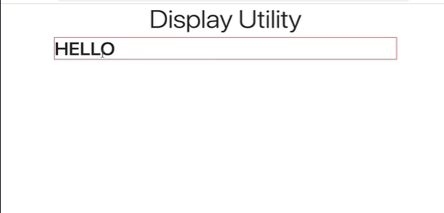

By default, this content is a block level element.

But if we want, we can say that this h1 is now inline by using the class *d-inline.* So, we write our code as follows.

*<div class= “container”>*

*<h1 class= “text-center display-4”>Display Utility</h1>*

*<h1 class= “border border-danger d-inline”>HELLO</h1>*

*</div>*

*Output:*

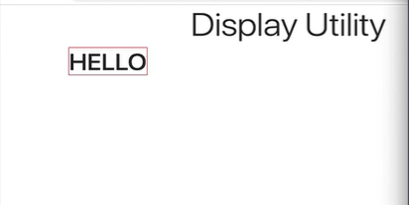

So, there we go, its now an inline level element.

That’s one way of using it. Another way of using this property is by using span.

*<div class= “container”>*

*<h1 class= “text-center display-4”>Display Utility</h1>*

*<h1 class= “border border-danger d-inline”>HELLO</h1>*

*<span class= “border border-success d-block”>HELLO</span>*

*</div>*

*Output:*

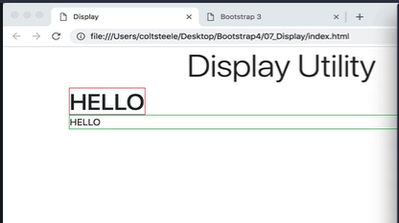

Now we will focus more on the responsive utilities using the breakpoints where we can hide and show things between different breakpoints. The syntax for that would be

*.d-{breakpoint}-{value} for sm, md, lg, and xl*

Now for example we want to hide a content as our screen hits extra large. Then our code will be like below

*<div class= “container”>*

*<h1 class= “text-center display-4”>Display Utility</h1>*

*<h1 class= “border border-danger d-inline”>HELLO</h1>*

*<span class= “border border-success d-block”>HELLO</span>*

*<h1 class= “****d-xl-none****”>HIDE ME ON XL</h1>*

*</div>*

*Output*

*Extra small, small, medium and large screen*

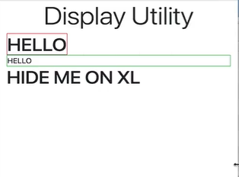

*Extra large screens*

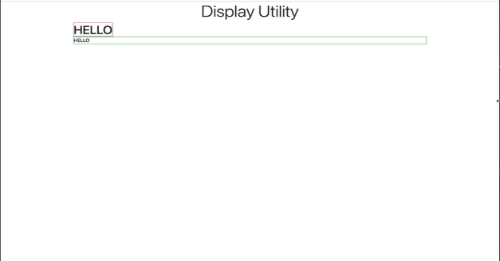

*<div class= “container”>*

*<h1 class= “text-center display-4”>Display Utility</h1>*

*<h1 class= “border border-danger d-inline”>HELLO</h1>*

*<span class= “border border-success d-block”>HELLO</span>*

*<h1 class= “****d-xl-none****”>HIDE ME ON XL</h1>*

*<h1 class= “****d-none d-lg-block d-xl-none****”>ALWAYS HIDDEN EXCEPT LG</h1>*

*</div>*

*Output:*

*For screens extra small, small and medium*

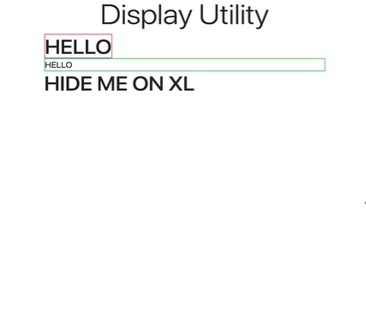

*Large*

